**WEB TECHNOLOGY LAB PROJECT**

**GADGETLY – AN ONLINE ELECTRONICS SHOPPING SYSTEM**

**TEAM MEMBERS:**

**B.SETHU MATHAVAN (2018506111)**

**A.SAI KIRAN (2018506101)**

**S.ADITYA SRIRAM (2018506008)**

**Technologies to be used:**

* Java swing
* Java Database Connectivity(**JDBC**)
* MYSQL

MySQL tables:

* Phone table
* Laptop table
* Television table
* Fitness Band table
* Earphone table
* Console table
* Cart table
* Customer table
* Payment table

**Home Page:**

Homepage contains category section and it has six buttons for each category. Based on user preference category will be chosen and each category contains list of products relevant to the category and are displayed.

**Product display page:**

The category sections available under homepage are:

* Mobile phones
* Laptops
* Television
* Gaming Consoles
* Earphones and Headphones
* Fitness Bands

The categories listed above have their own product page containing product image, name, specifications and details which are also maintained in database tables to describe each product price and available stock.

The database tables consist of product ID, Brand name, Model name, price, availability(stock).These constraints are common for all the products listed above.

Under every product **Add to Cart button** is displayed. If the user selects the product that he/she decided to buy, then add to cart button is clicked under user selected product. On clicking **Add to Cart button** it checks whether the selected product stock is available in desired product database table . If available in stock quantity of selected product is reduced from the desired product table and product details added to cart .If not available in stock dialogue box pop up with a message **“ITEM NOT IN STOCK”.**

**Cart:**

Cart has specific database table to display the product details selected by the user. Clicking **Add to Cart button** in product page adds product details to cart .to check the added product details **Show Cart Contents button** is clicked which is available in cart page. The cart database table consists of Product ID, product name, price to display the added product details.

**Remove from cart:**

Remove cart page contains **Product ID text box** and **Remove Product button**. If a user wants to remove a product from cart, then he/she has to enter valid product id in **Product ID text** **box** and **Remove Product button** is clicked. On clicking **Remove Product button** it checks whether the entered product ID is available in cart table. If available it removes the product details based on the product ID entered and adds that product into desired product table to restore the stock. If not available in cart table, a dialogue box appears with a message **“ITEM NOT IN CART”.**

**Customer details page:**

Customer details page contains customer name, address, city, state, phone number, pin code textbox and **save details and proceed for payment button**. After the user entered their details in desired textbox **Save details and proceed for payment button** is clicked. On clicking that button it adds the customer’s details in customer table to maintain customer information database.

**Payment Gateway:**

Payment gateway page contains creditcard number, card expiry date, CVV, name on card , pin number textboxes and **Submit button**. After the user enters their payment details correctly in desired textbox submit button is clicked. on clicking **submit button** it checks the payment table data matches with current payment details. If matched a dialogue box appears with a message **“PAYMENT SUCCESSFUL.”** If a match is not found, a dialogue box appears with a message **“INVALID CARD DETAILS”.**

**Cost Estimation :-**

We use the Application Composition Model for project estimation. In this model size is first estimated using Object Points. Object Points are easy to identify and count. Object Points defines screen, reports, third generation (3GL) modules as objects.

Number of screens in the application = 11

Each screen consists of 12 views, 4 client tables and 2 server tables.

Number of reports = 4

This consists of 6 sections, 2 client tables and 1 server table each.

The complexity weight of each object is given by

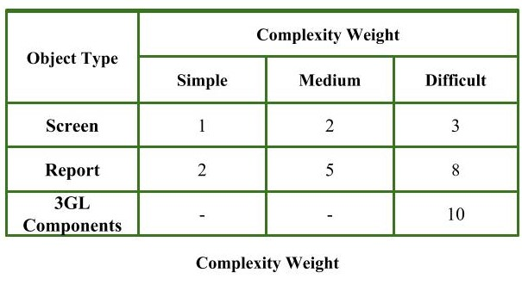

The complexity levels (simple, medium, difficult) are determined by the following tables :

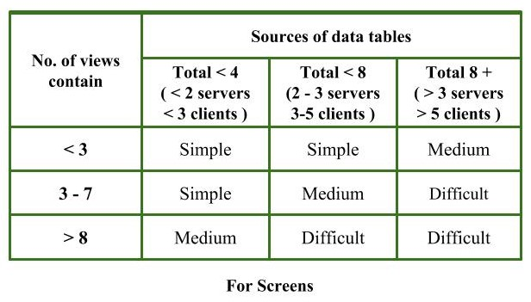

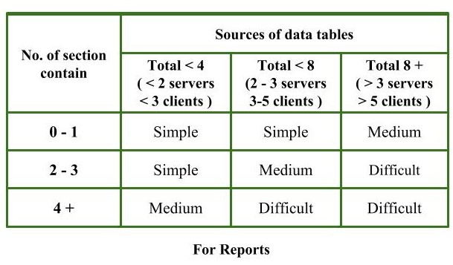

Hence, for our project, the complexity level of screens is difficult.

Complexity weight = 3

Complexity level of reports is medium.

Complexity weight = 5

Therefore, object points = 3*11 + 5*4 = 53

Total number of objects = 15

Here, we reuse 3 screen components – login/signup page, the categories page and the cart page.

Thus, percentage reuse = (3/15)*100 = 20%

NOP = 53*(100-20)/100 = (53*80)/100 = 42.4

The PROD table :

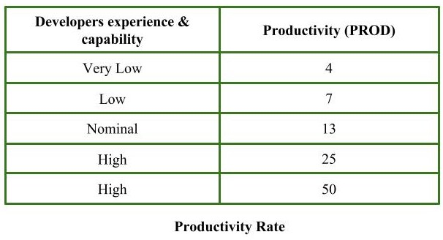

Developer’s experience and capabity are nominal.

Thus, PROD = 13

Estimated effort = 42.4/13 = 3.261 person-month